Bansilal Ramnath Agarwal Charitable Trust’s
Vishwakarma Institute of Information Technology
Pune – 411048



Preliminary Project Report
On

Feedback System

Submitted By
Abbas Hashmi 17U096
Adesh Gaikwad 17U134
Burhanuddin J.G. 17U099

Department of Computer Engineering
Savitribai Phule Pune University, Pune
Year 2019-2020

CERTIFICATE

This is to certify that the following students of T.Y. Computer, Vishwakarma Institute of Information Technology, Pune

Abbas Hashmi ( 17U096 )
Adesh Gaikwad (17U134 )
Burhanuddin J.G. (17U099 )

have successfully completed the project report on

Feedback System

in the fulfillment of the requirements for the project completion of T.Y. Computer in academic year 2019-2020.

Project Guide HOD

Table of Contents
1. Introduction 4
1.1 Purpose 4
1.2 Scope 4
1.3 Technologies to be used 4
1.4 Overview 4
2. Overall Description 4
2.1 Use-Case Model 4
2.2 Architecture diagram & database design 5
2.3 Assumptions and Dependencies 5
3. Specific Requirements 15

4. Conclusion 15

Software Requirements Specification

Introduction

The ‘Feedback System’ web application gives the facility to create feedback forms and record the survey given by the users.

Purpose

To give the user a simple platform and interface to create feedback forms as per their choice which will give them the opportunity to observe the feedbacks given by the users.

Scope

This project can be used by small organisations used as schools, colleges and medium scaled business.

Technologies to be used

- Ruby on Rails
- Bootstrap

Overview

We will see what the project architecture is and how the user can navigate through the project.

Overall Description

Use-Case Model
Create the forms

Edit the forms

Admin
View the forms

View the responses

Fill and submit the forms

Delete the forms

User

Architecture diagram & database design

The architecture used is model, view, controller architecture and the database used is PostgreSql.

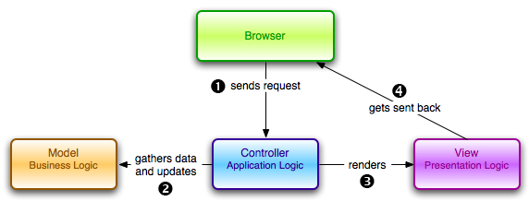

Assumptions and Dependencies

The system should have latest version of rails installed on their system to avoid compatibilty issues.

Specific Requirements

Use-Case Reports

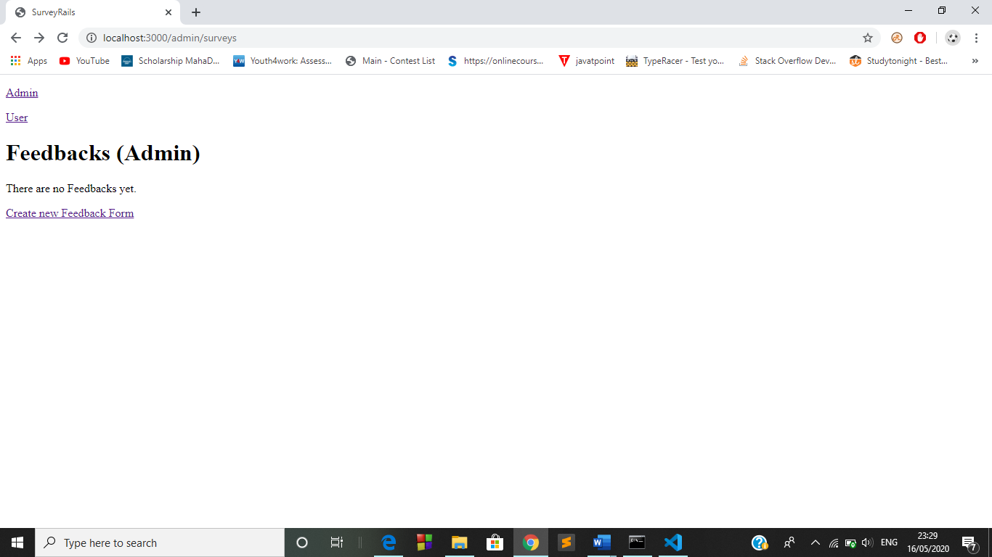

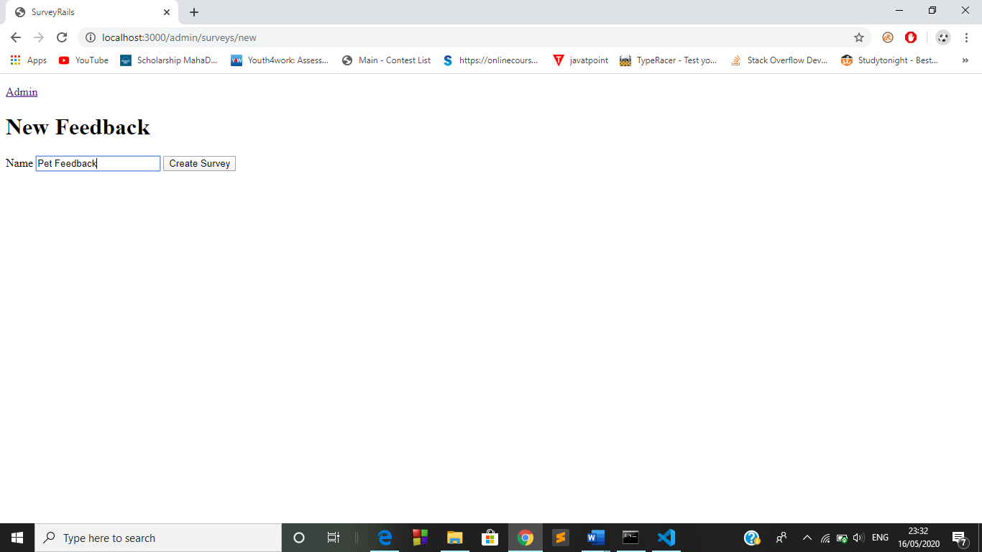
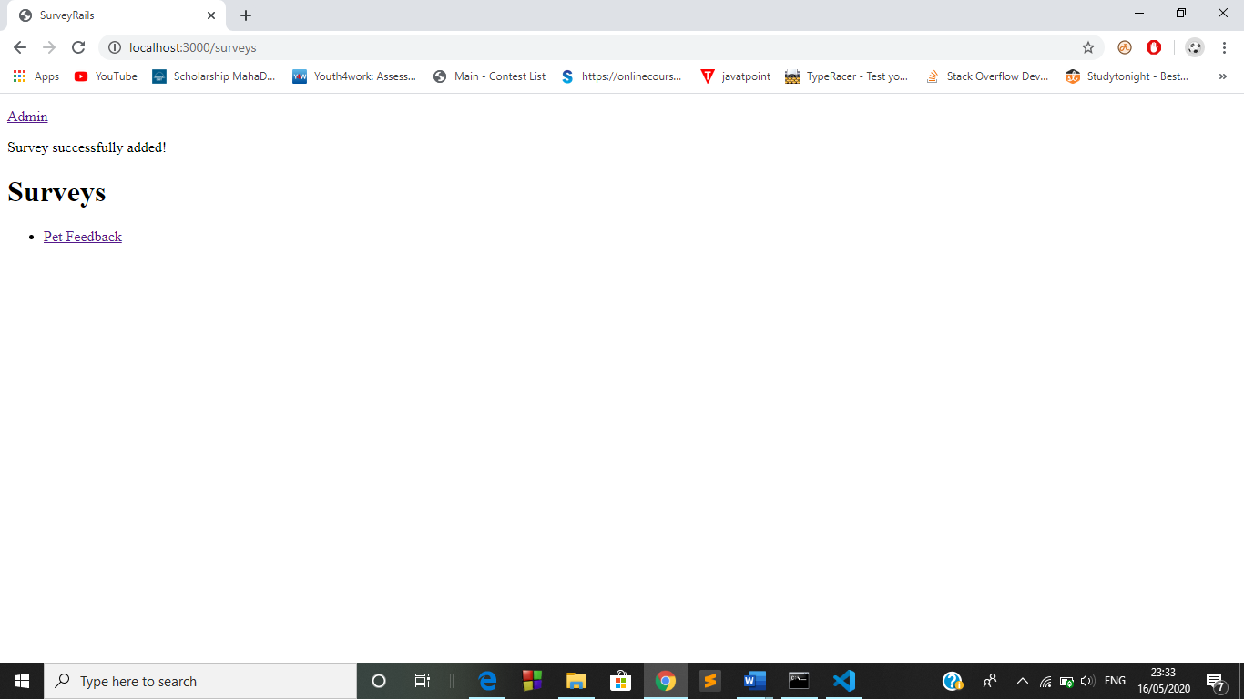

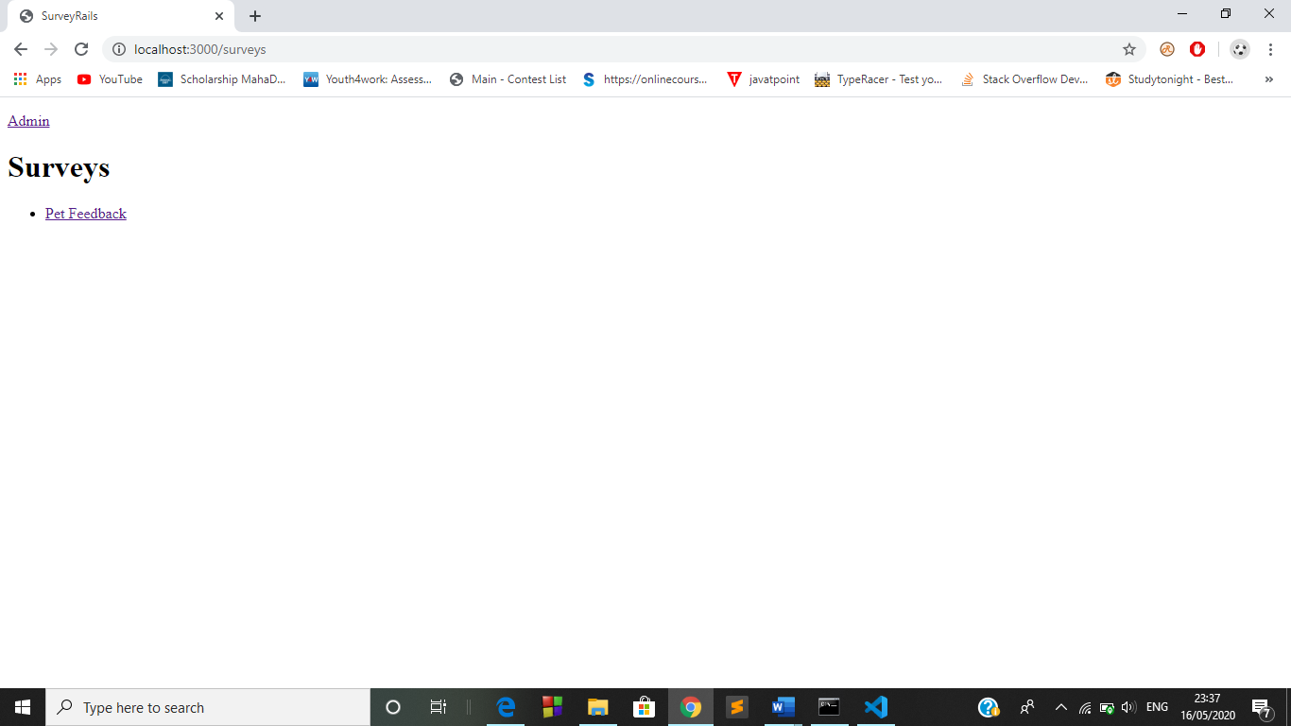

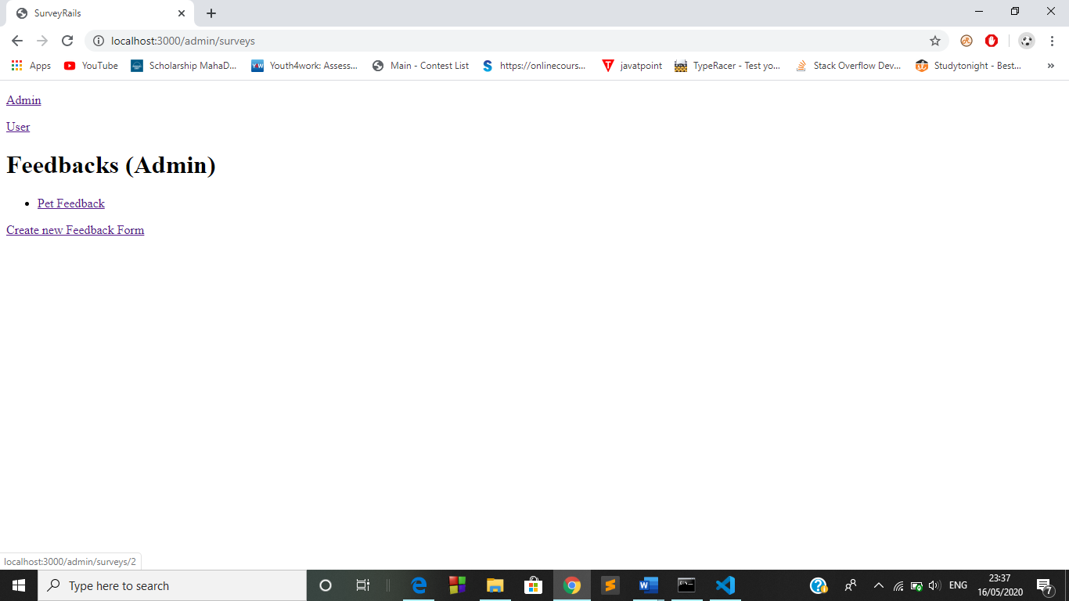

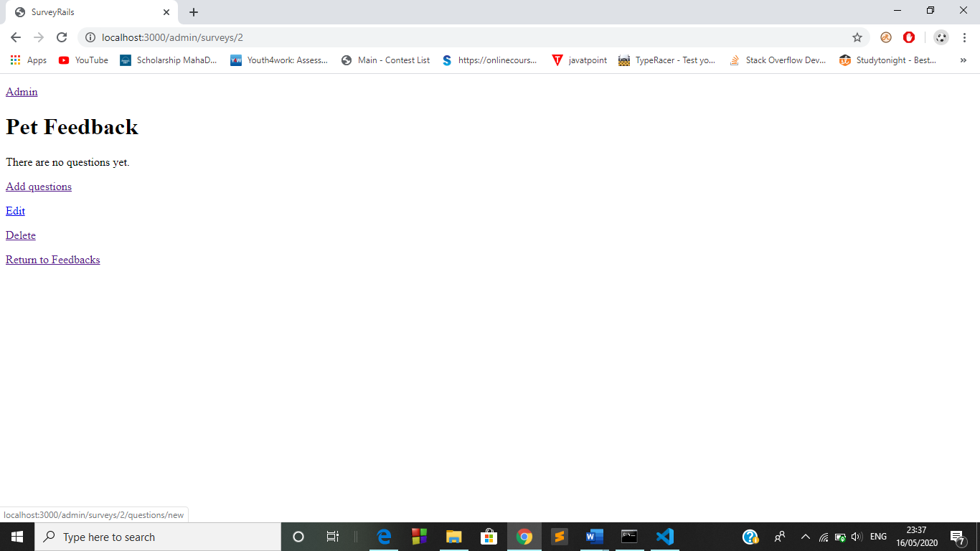

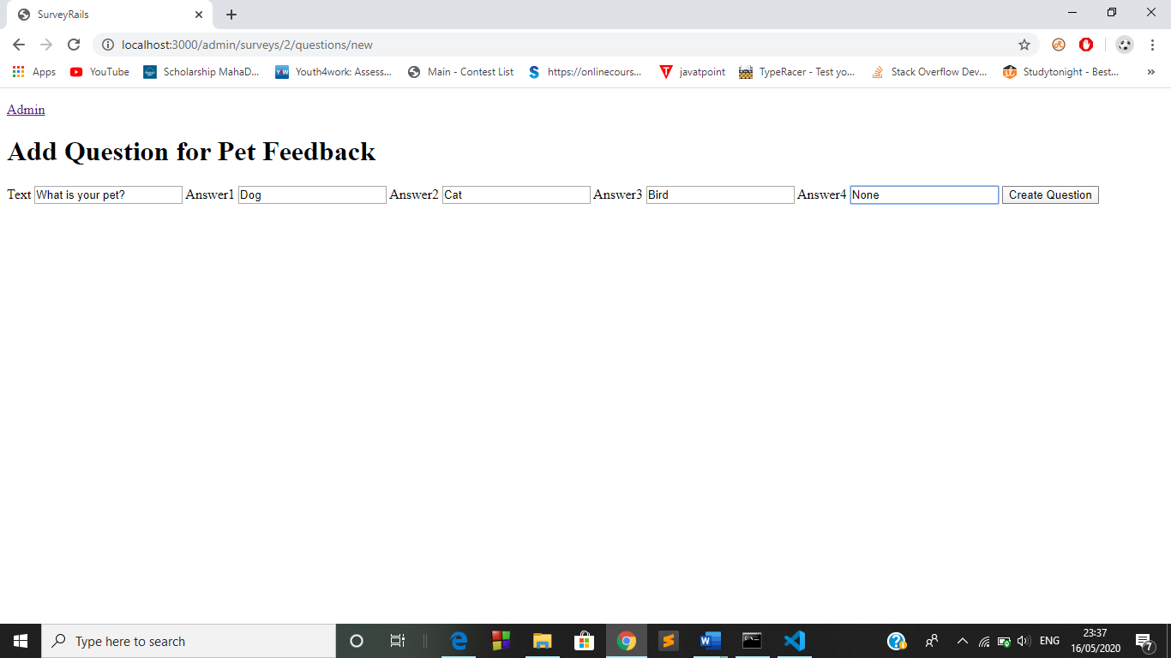

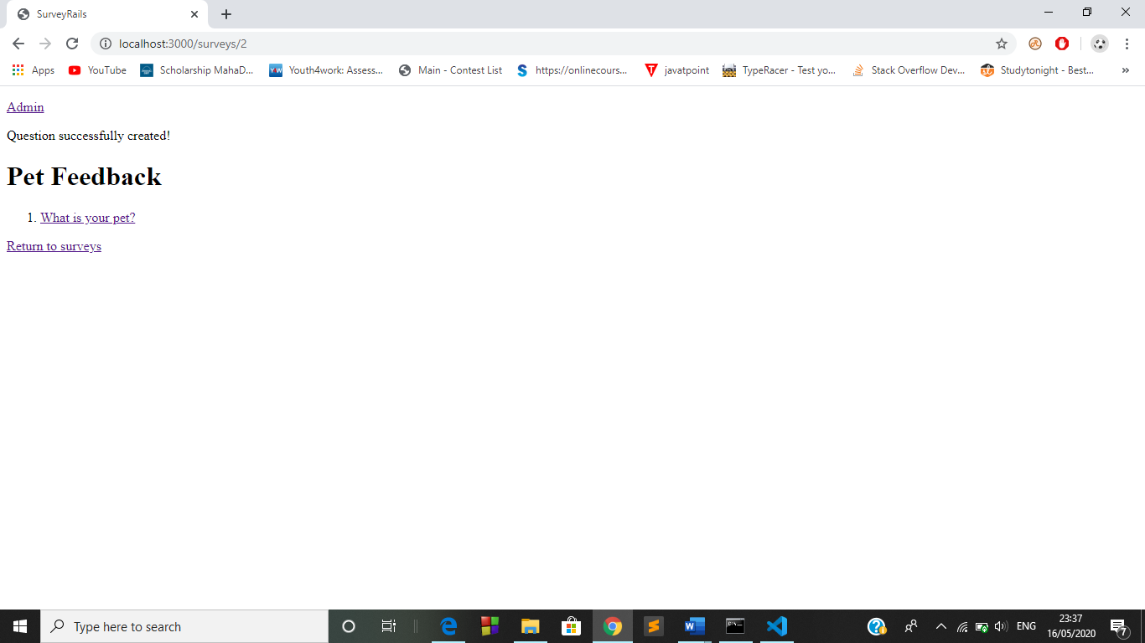

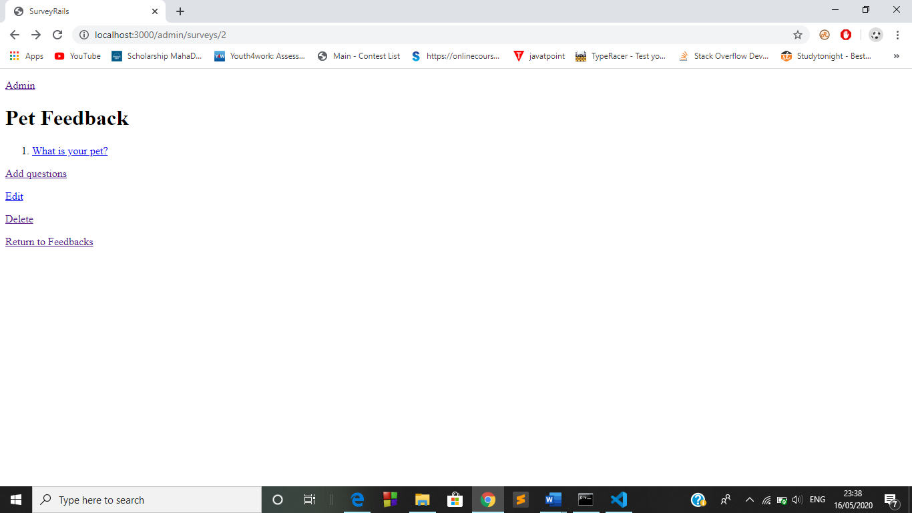

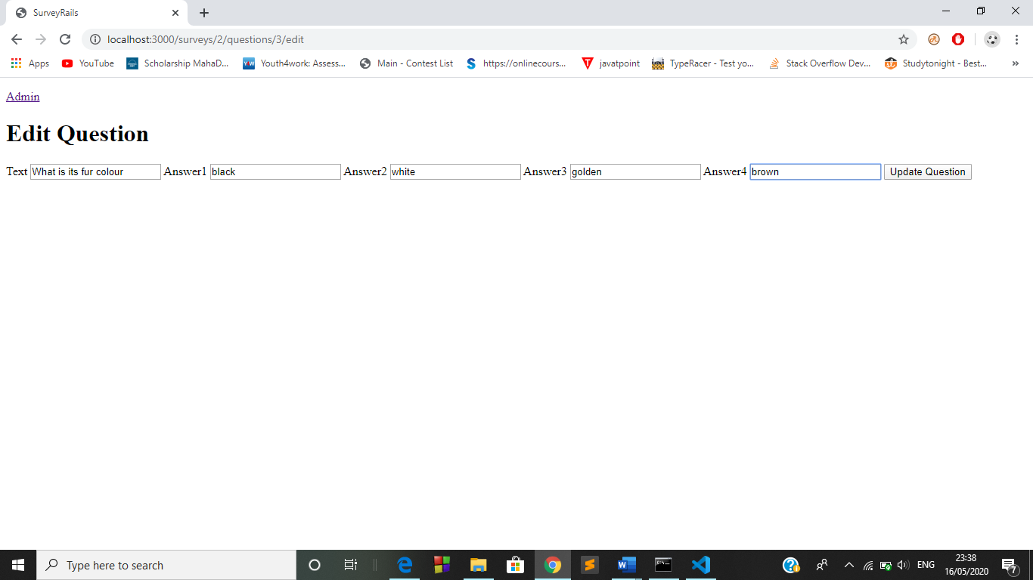

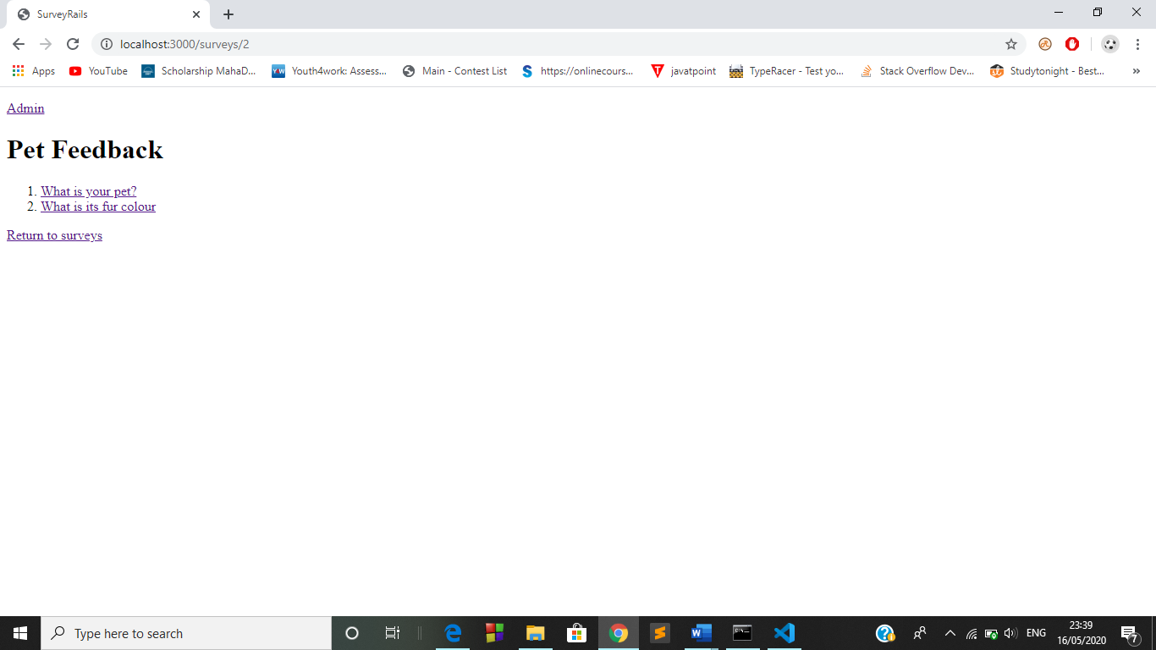

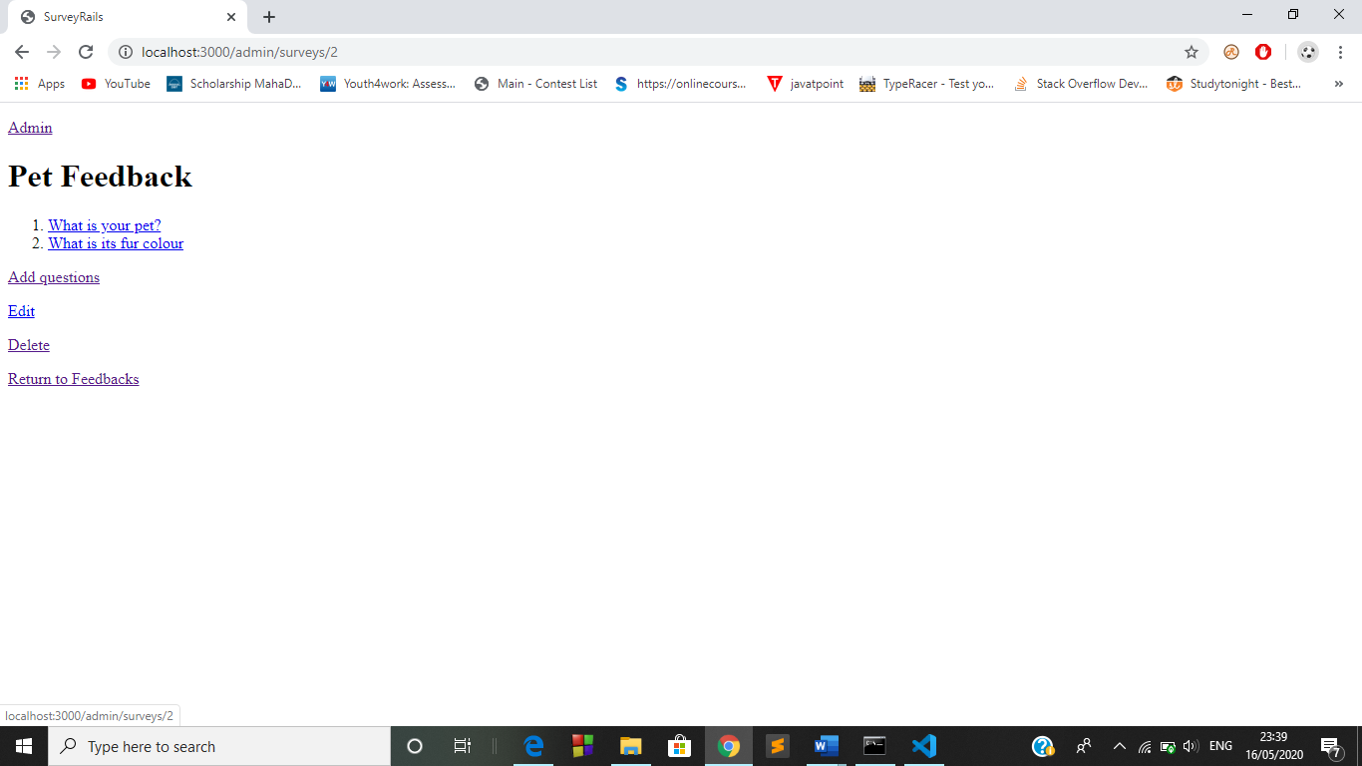
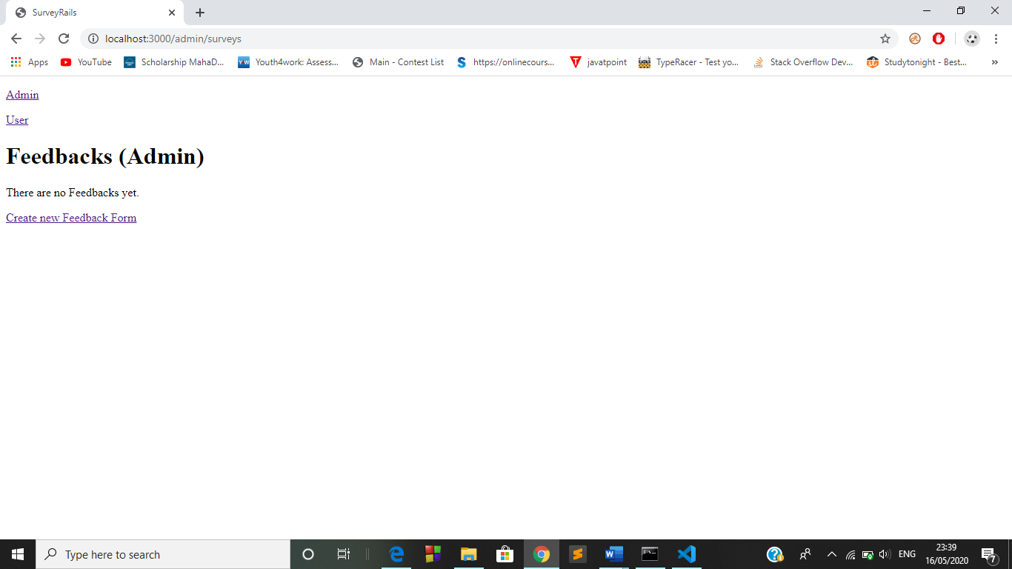

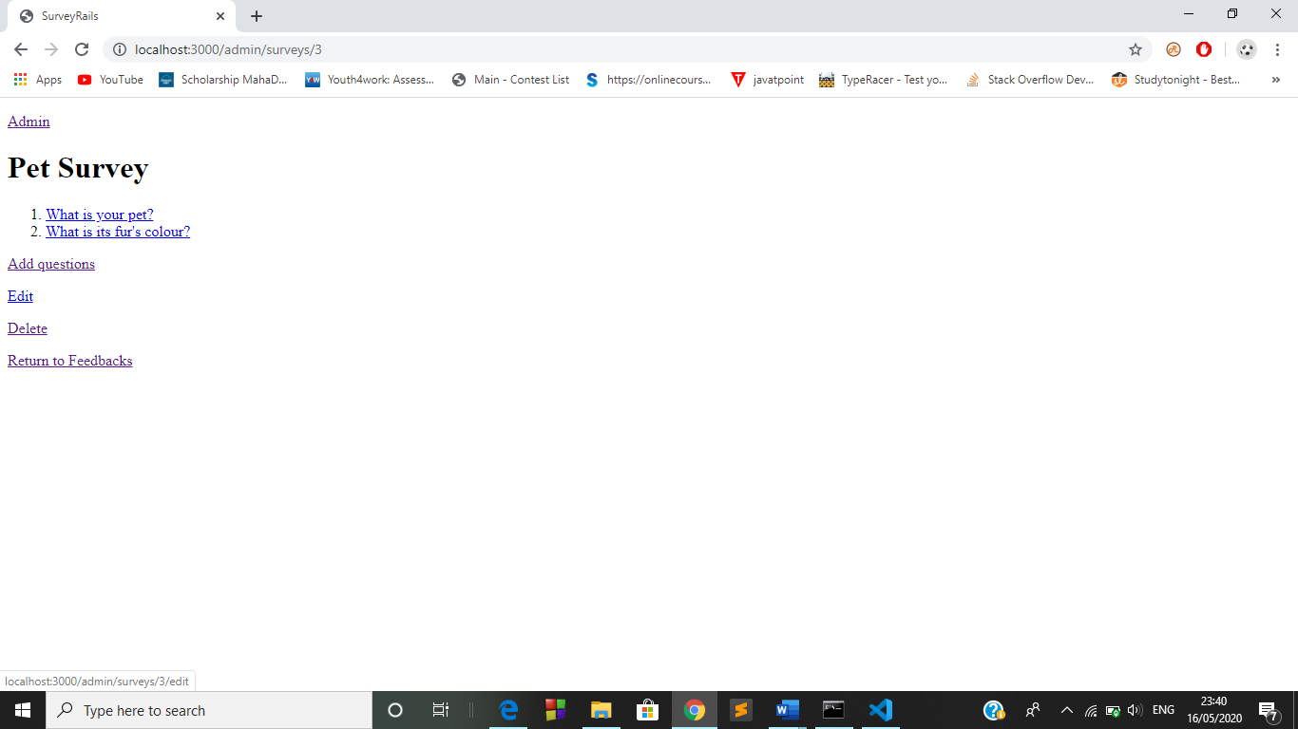

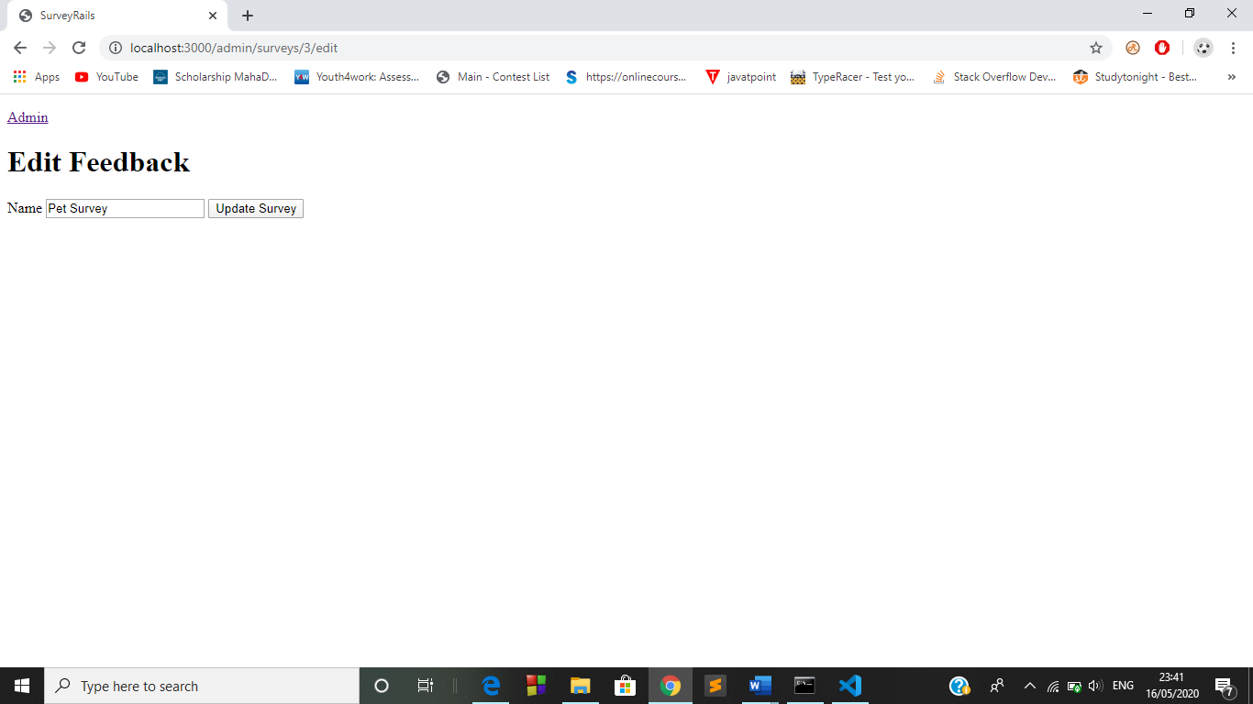

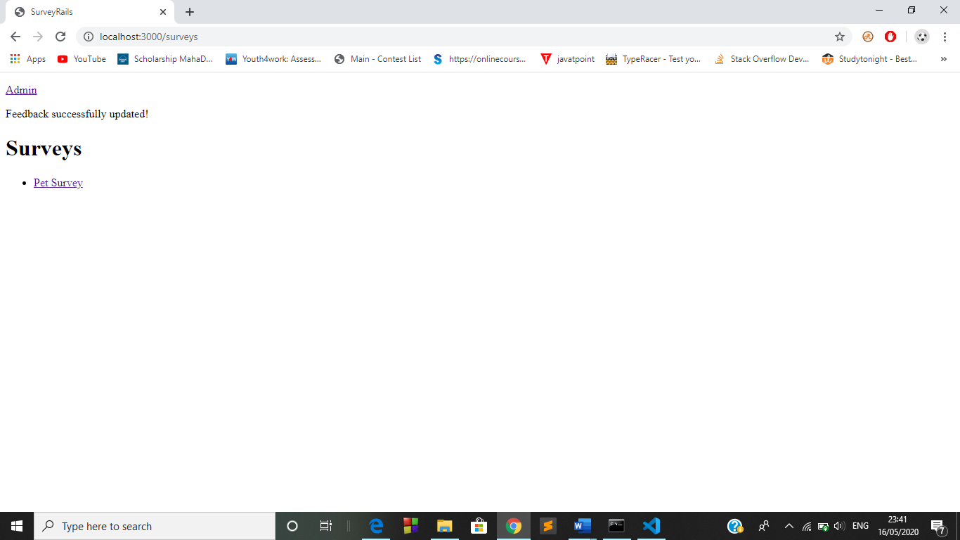

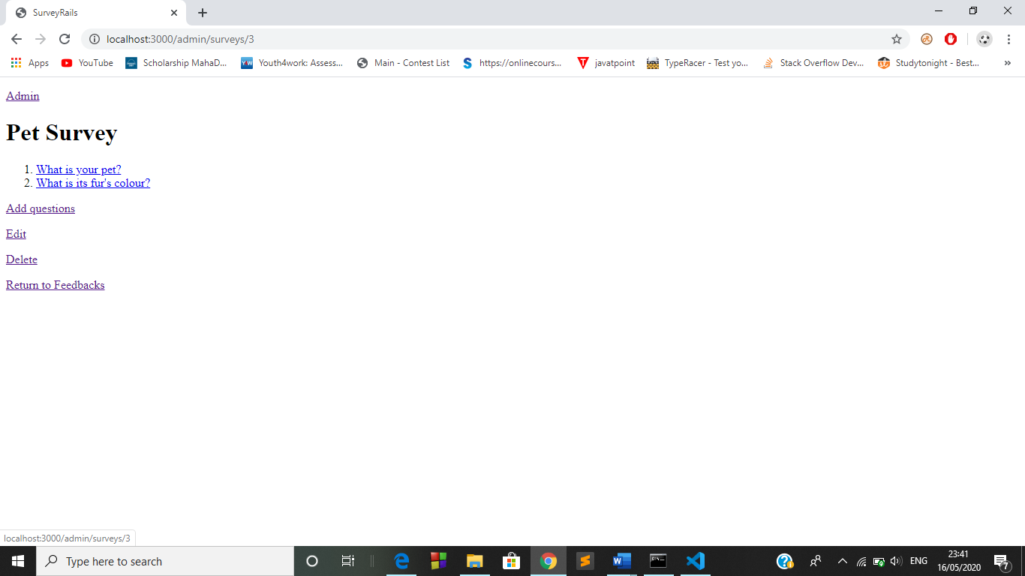

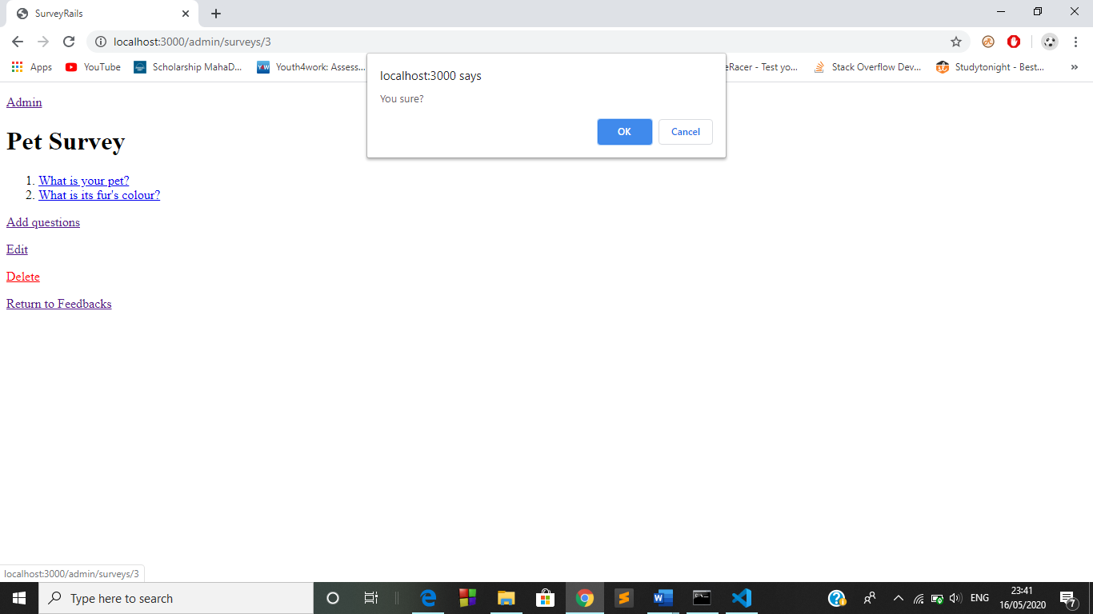

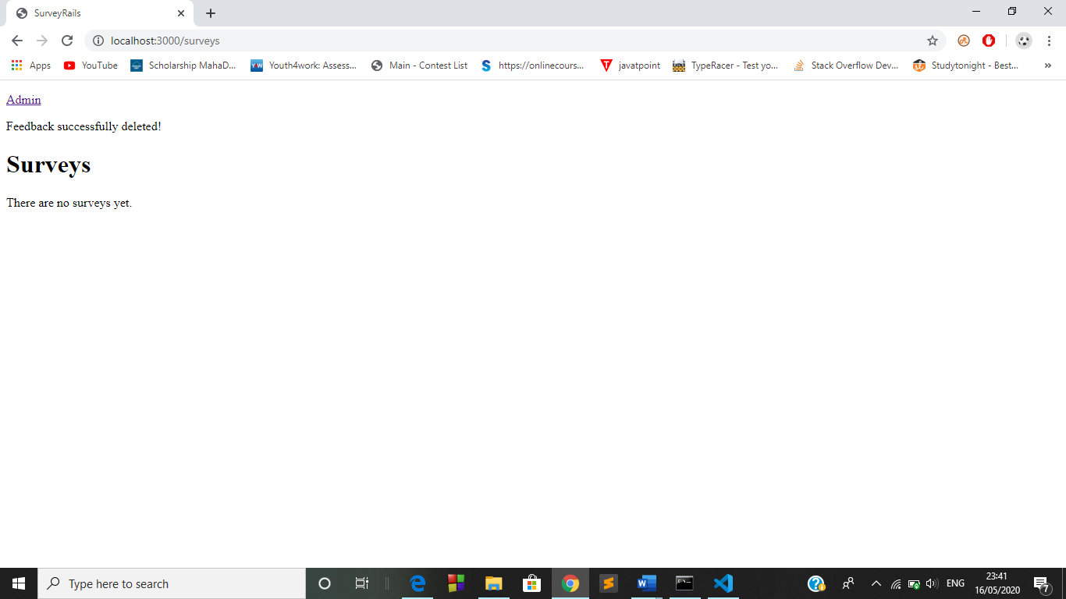

Supplementary Requirements

The system should have latest version of rails running on their system and any updated browser.

Conclusion

The “Feedback System” definitely helps anyone who needs to get feedback regarding anything. It will really help in improving those things which need attention after getting and analysing the feedbacks from the users.

